May 4th, 2008
Hi
Last Saturday was the last run for the season though the conditions yesterday were quite good for a run. I did not do any exercise this past week. I will probably start again next week.
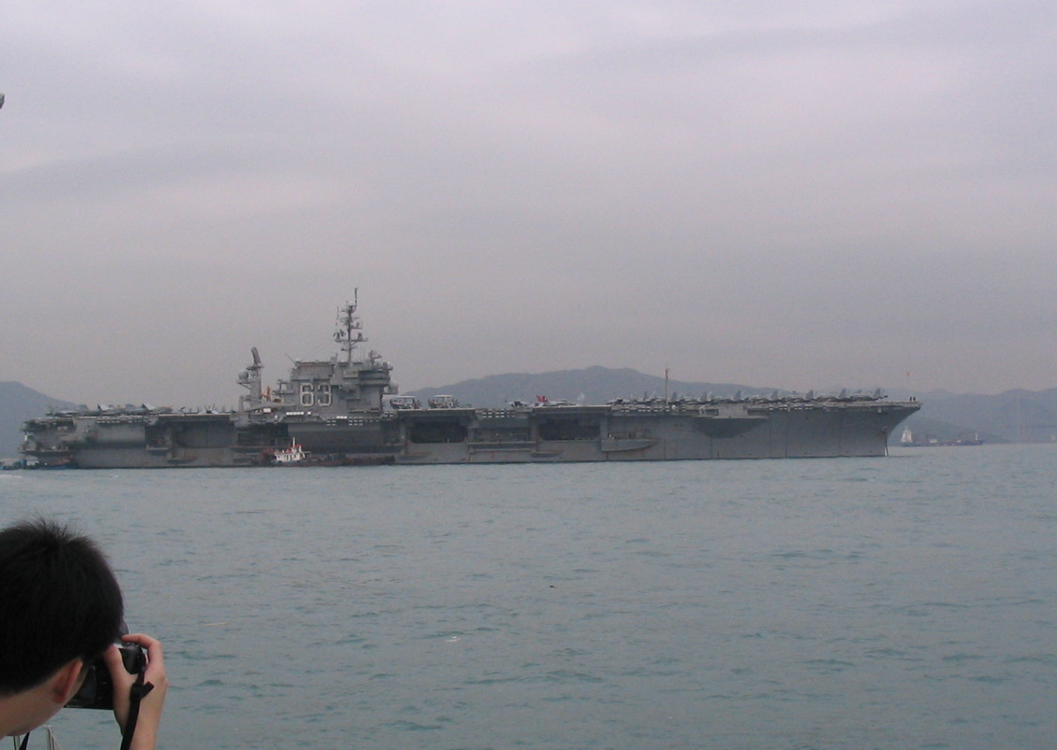
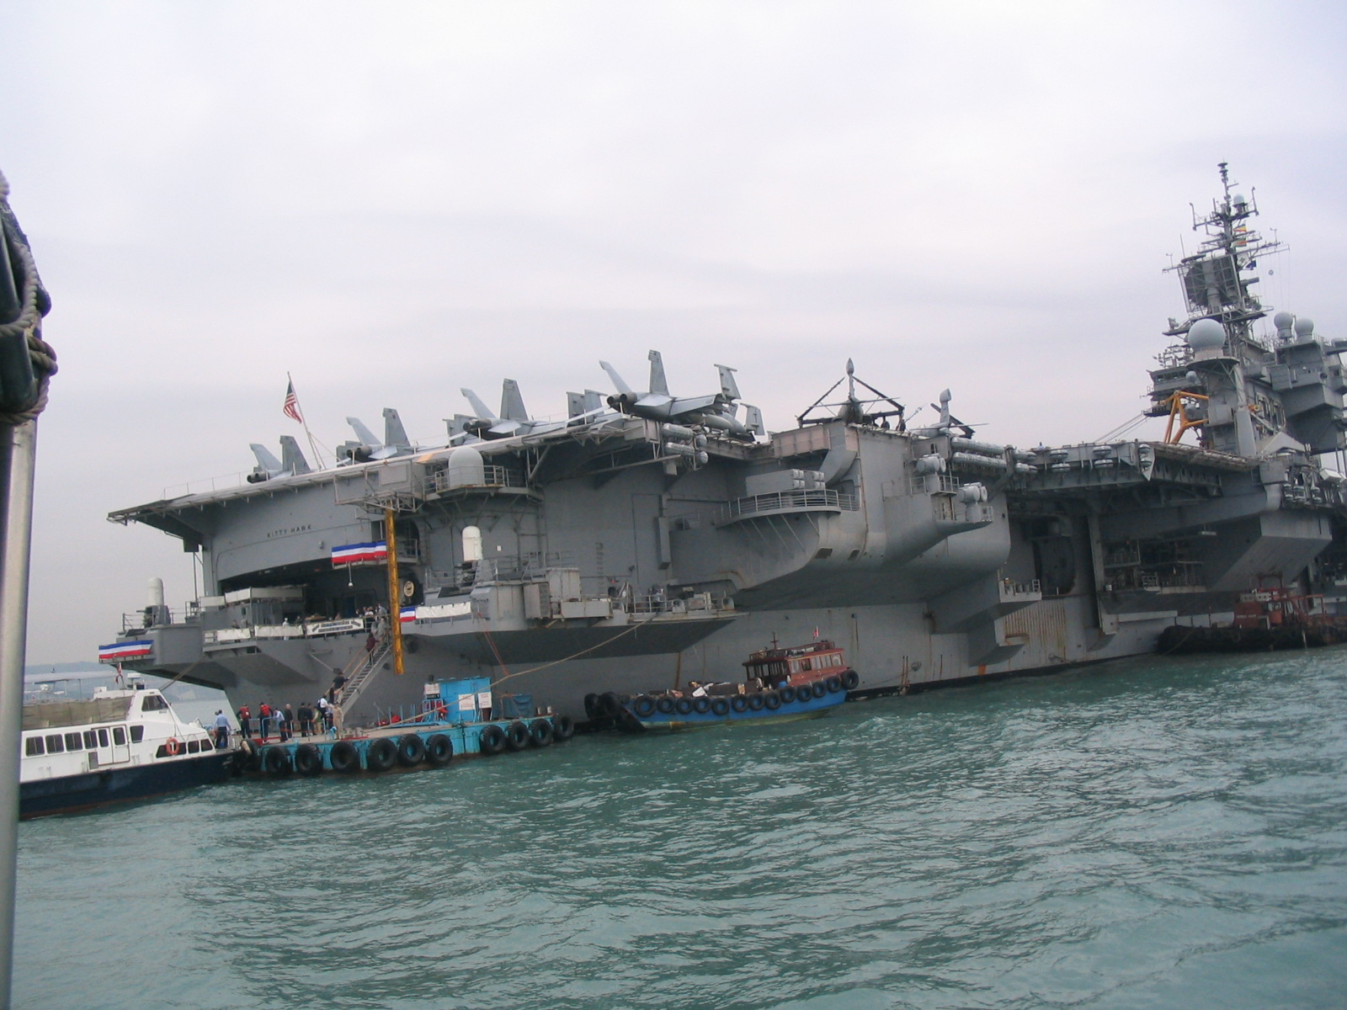
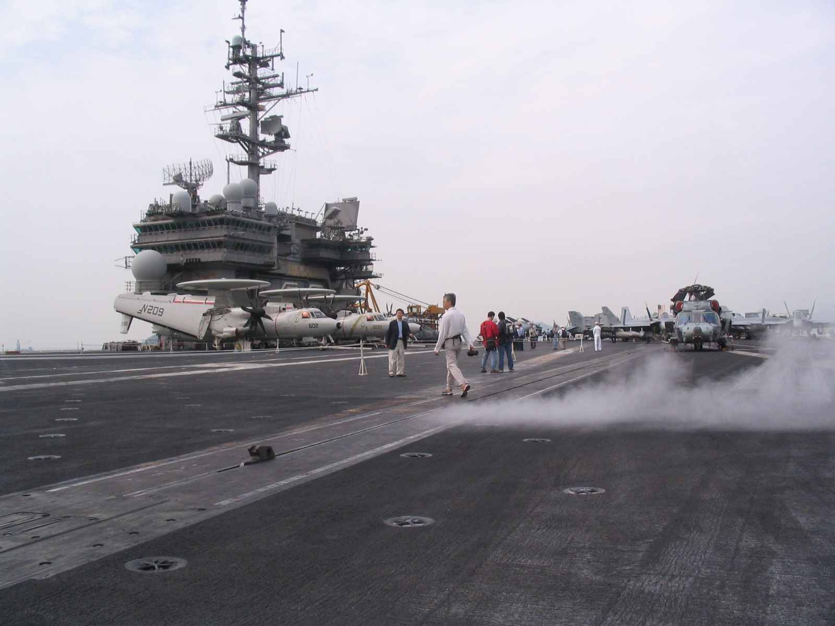
On Tuesday, I was up early at 5:45 am to be in time for the visit to the USS Kitty Hawk. Had to be at Fenwick/Servicemen’s pier (next to the Cultural Centre) by 8 am. As I said last week, the Stanford Alumni Association had arranged for five people to visit the ship. I could not understand why it was restricted to just five. However, I understood on arriving at the pier. The five were just part of a group of about 100, made up of people from various groups. So, I suppose each group, such as Stanford, was allocated just a small number of places. I only actually met one of the other Stanford people. At 8:30 am we were ferried by water taxi to the ship, which was anchored closer to the Tsing Ma suspension bridge that to HK Island. It was not a bad tour though there were only a few parts they took us to. On arrival, which was in the hanger, the 100 people were divided into groups of 20. The hanger is big but not overwhelming; only a few of the 75 aircraft were in it; most on the flight deck. Then to the forecastle (for you non-naval types, pronounced ‘folk-sul’) to the anchor room (each link of the anchor weights 365 lbs). Then up to the flight deck and back to the hanger again. I wanted to see the engine room and the bridge but they were not included. Still, an interesting visit. Yes, this is the last visit of the ship to HK as it is to be decommissioned next year, then presumably scrapped.

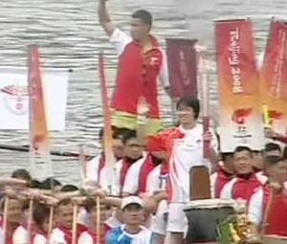
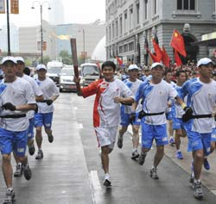
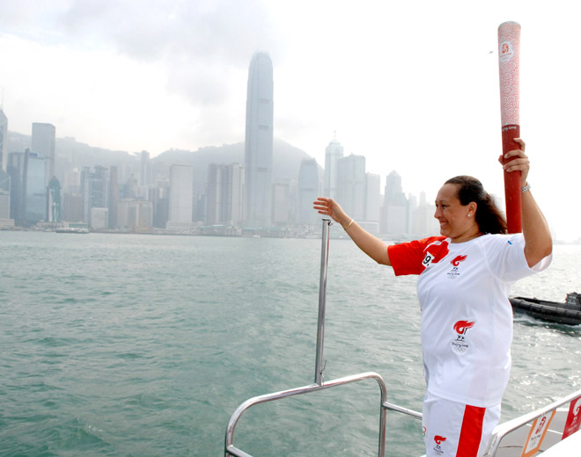
On Wednesday, the Olympic flame arrived in HK amidst much hype (and political 'interference'). Many school kids bussed to the airport to cheer and wave flags. The actual torch relay was on Friday. The weather was drizzly for a lot of the relay. It started in TST by the Cultural Centre, then proceeded to the Tsing Yi bridge, on to Shatin (and carried across the river by dragon boat) and ended at Bauhinia square by the Convention Centre at about 5 pm. I did not follow it at all. Only 1/3 of the torchbearers were athletes; the others were celebrities and pro-China people. There were not many protests, and none of these interfered with the relay itself. (Nearly all known overseas protesters coming to HK were not allowed in and were put on return flights!!) For what protests there were, mainly by locals, many of the onlookers did not take too kindly to them. After the relay had finished, the torch was taken (by plane!!!) to Macau. From there it will tour about 100 cities in China before ending in Beijing for the games.

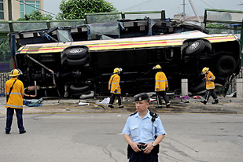
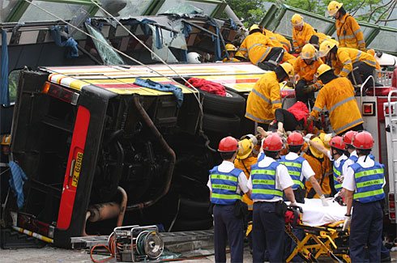
Thursday (May 1st) was a public holiday (May Day). Early that morning, there was a terrible local tour bus crash in Sai Kung. The bus, travelling very fast down a hill, failed to negotiate a roundabout, flipped on its side, crashed into a wall and flattening the roof onto the passengers. Altogether, 18 people were killed (all women!!!) and about 44 serious injured. The driver was arrested for dangerous driving. He said his brakes failed, but on the TV news, skid/brake marks could be clearly seen on the road, suggesting that the brakes were OK. This was the worst accident since the KMB bus went off the viaduct about five years ago.
Nadine's Psychology department graduation on Thursday and general graduation on Friday. She talked to me on Skype about them.

I did a little experiment to find out how much fresh water I use (this does not include toilet flushing water, which is seawater). I found that the approximate amount I would use for one bath (i.e. a full bath with a few top-ups when the water gets cold) is about the same as for all other uses – cooking, washing, etc.

That’s it for now.
Cheers

